**Task 3**

**Part A**

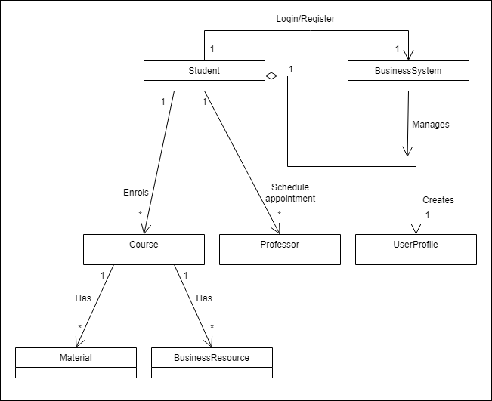

1. BusinessSystem:

* Responsible for managing the overall system.
* Responsible for maintaining lists of students, courses, professors, and business resources.
* Provides methods to register students, add courses, add professors, add resources, and retrieve course information.

1. Student:

* Represents a student in the system.
* Responsible for managing the student's profile, including personal information.
* Provides methods for enrolling in courses, submitting assignments, viewing grades, scheduling appointments, joining discussion forums, accessing internship and job opportunities, accessing the library, and receiving notifications.

1. Course:

* Represents a business course.
* Responsible for managing course-related information.
* Provides methods for viewing course materials and assignments.

1. Professor:

* Represents a professor/instructor.
* Responsible for managing professor-related information.
* Provides methods for viewing appointments with students.

1. Material:

* Represents course materials (e.g., lecture slides, handouts).
* Belongs to a specific course.
* Responsible for managing material-related information.
* Does not have specific methods defined in the class diagram.

1. BusinessResource:

* Represents business-related resources (e.g., e-books, research papers).
* Belongs to a specific course.
* Responsible for managing resource-related information.
* Provides a method for downloading the resource.

**Part B**

Facade pattern:

The facade pattern provides a simplified interface to a complex subsystem, hiding its complexity and providing a unified interface for clients to interact with the subsystem. In this case, the BusinessSystem class can act as a facade, providing a simplified interface to the various functionalities and entities within the system.

